Plan 1: NO INDEXES
Operators:
- Table Scan for Customers and Orders
- Hash Match (Inner Join)
Subtree Cost: 0.0962102
Execution Time: to check screenshot in Message

Reason for this plan:
No indexes exist = optimizer has zero shortcuts
Must read ALL 2000 Customers + ALL 4000 Orders
Hash Match chosen = cheapest join for large inputs

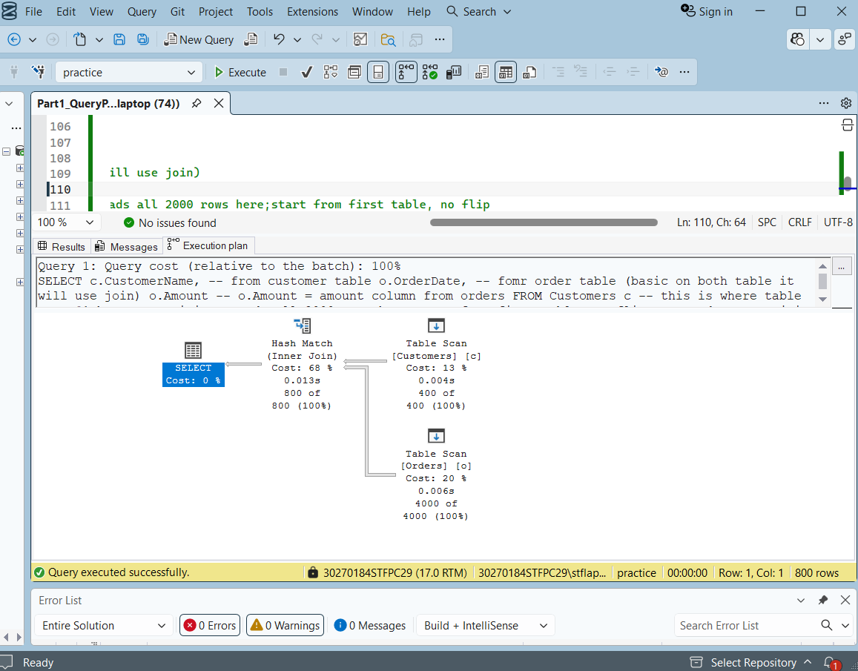
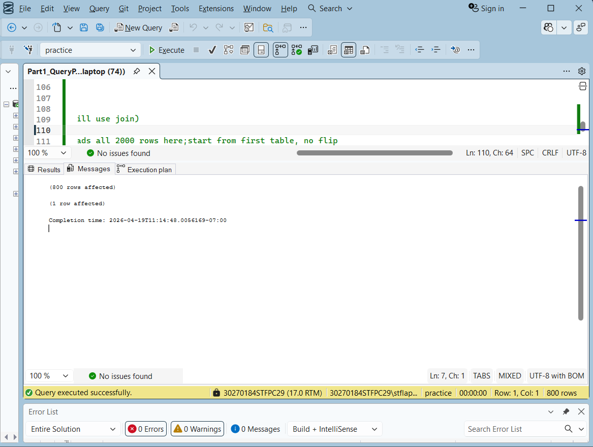
Plan 2: PK on Cutometer
Operators:
- Clustered Index Scan (Cusotners)
- Table Scan (Orders)
- Hash Match (Inner Join)
Subtree Cost: ~ 0.0958
Execution Time: to see the Message
This plan changed reason:
PK added = Clustered Index created on CustomerID
Customers icon changed Table Scan → CI Scan
Still scans all rows because WHERE is on City not ID

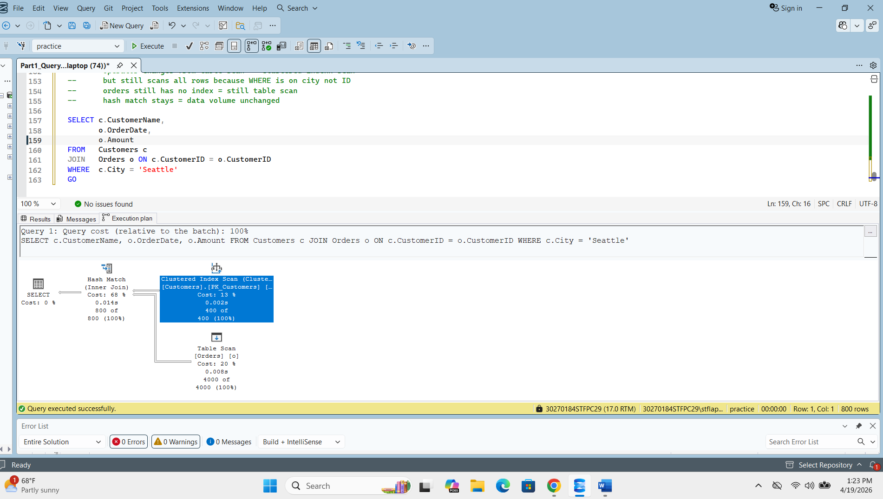
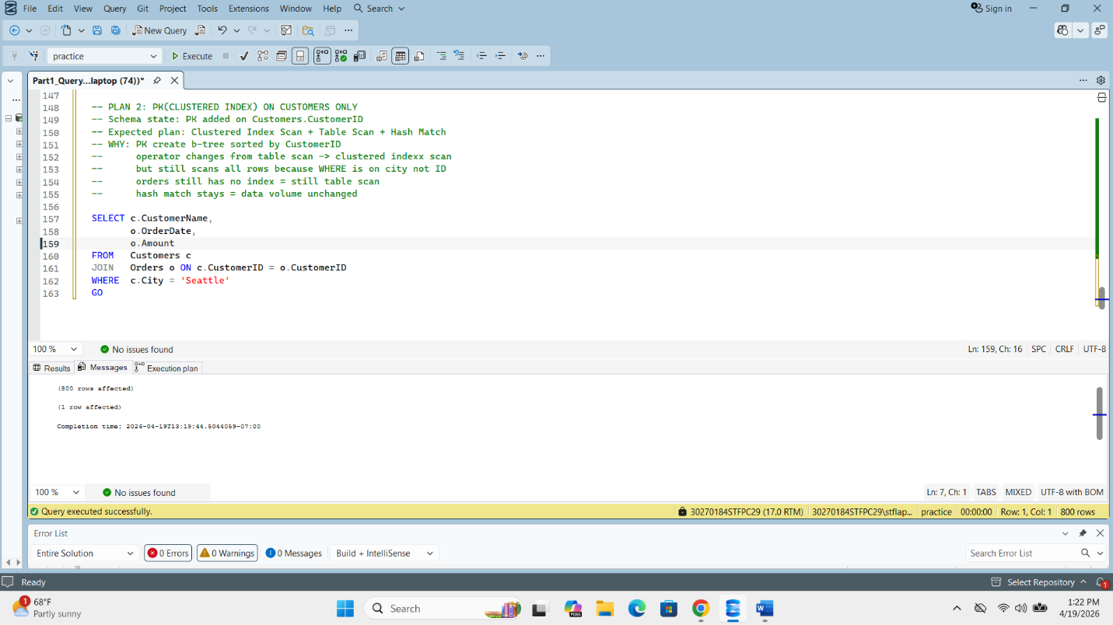
Plan 3: PK on Both Tables
Operators:
- Clustered Index Scan [Customers].[PK_Customers]
- Clustered Index Scan [Orders].[PK_Orders]
- Hash Match (Inner Join)

Subtree Cost: 0.0954695
Execution Time: see the Message on screenshot

WHY this plan changed:
PK added on Orders = Clustered Index created on OrderID
Orders icon changed Table Scan → CI Scan
Hash Match stays because Orders sorted by OrderID not CustomerID
Merge Join impossible = needs both sides sorted by join key
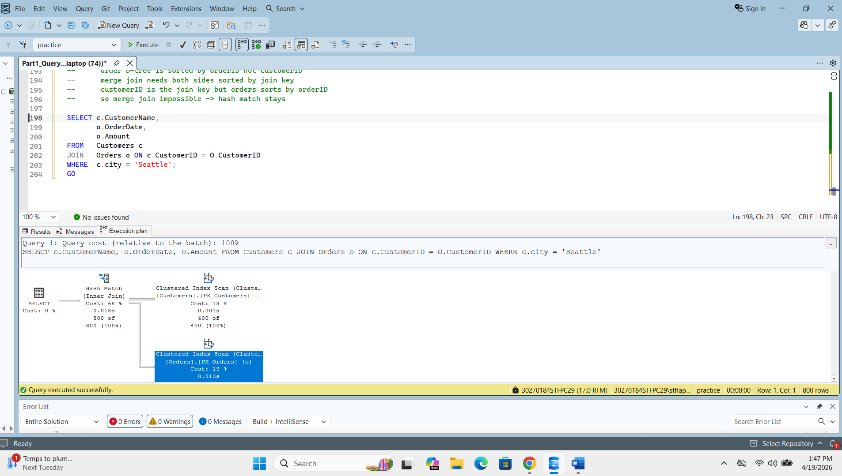
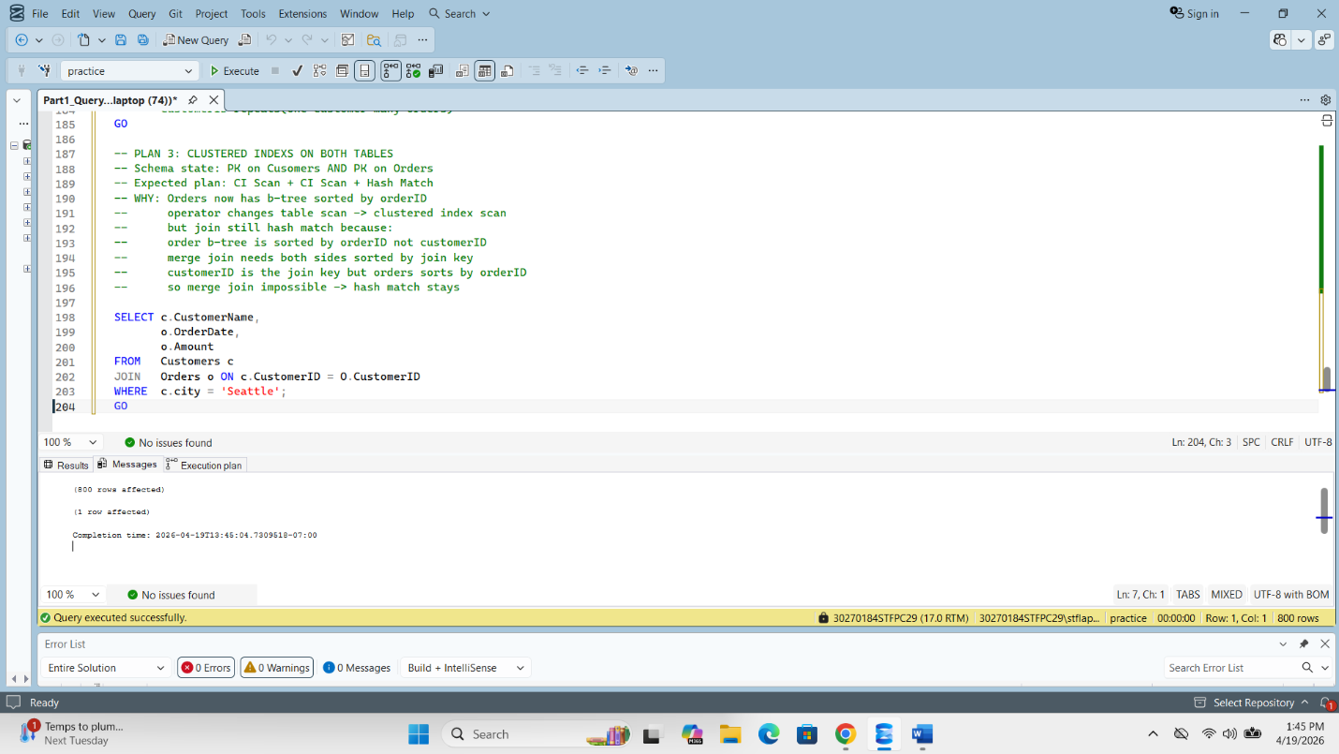
Plan 4: Non-Clustered Index on Customers.City
(20% Seattle = 400 rows):
Result: Optimizer IGNORED index!
WHY: 400 Key Lookups cost > CI Scan cost
Optimizer correctly chose CI Scan = cheaper!

ATTEMPT 3 (Query hint forced):
[paste execution plan screenshot here]
[paste messages screenshot here]

Operators:
- Index Seek (NonClustered) [IX_Customers_City]
- Key Lookup (Clustered) [PK_Customers]
- Nested Loops (Inner Join)
- Clustered Index Scan [Orders].[PK_Orders]
- Hash Match (Inner Join)

Subtree Cost: 0.1179200
Execution Time: (your time)

WHY this plan changed:
IX_Customers_City added on City column
Forced with query hint: WITH (INDEX(IX_Customers_City))
Index Seek appeared = jumps directly to Seattle rows
Key Lookup appeared = CustomerName not in index
= must fetch from clustered index
Nested Loops chosen = outer input shrunk to 100 rows
Cost INCREASED vs Plan 3 = proves optimizer was RIGHT!
Optimizer correctly preferred CI Scan naturally!

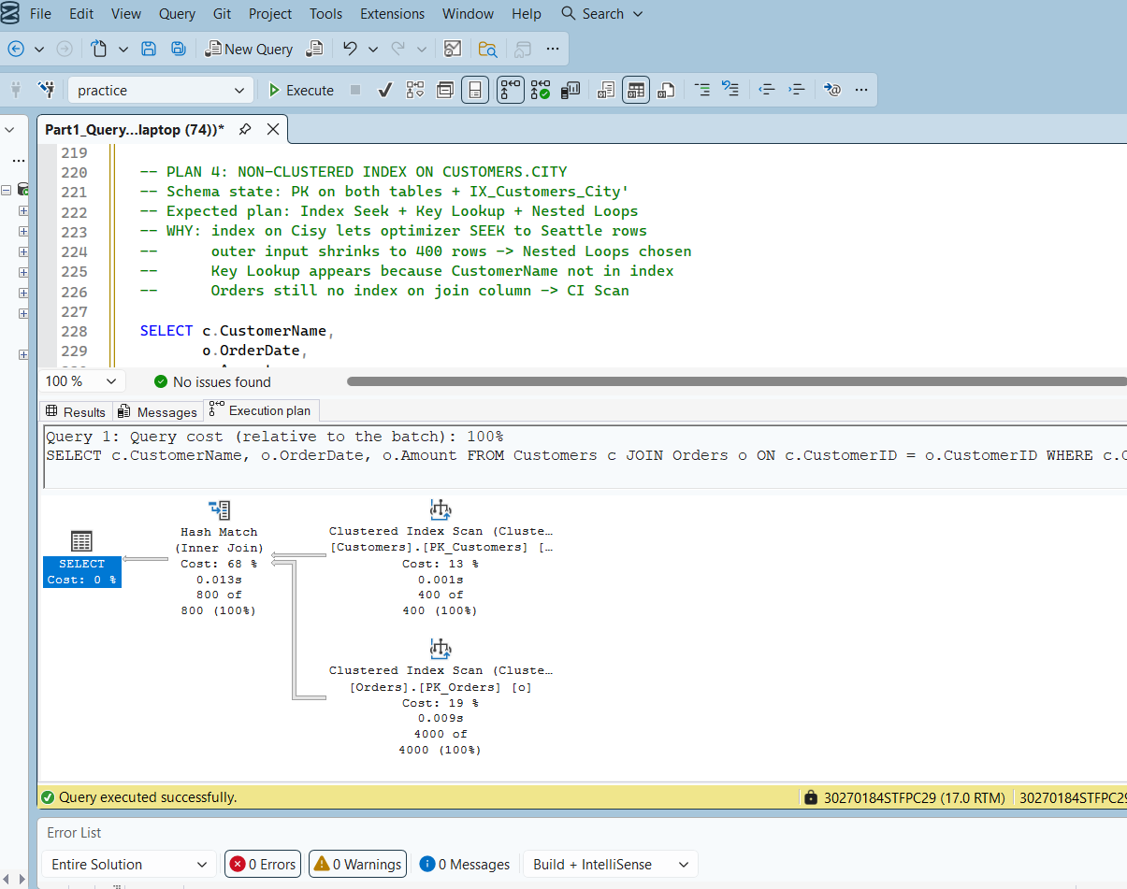
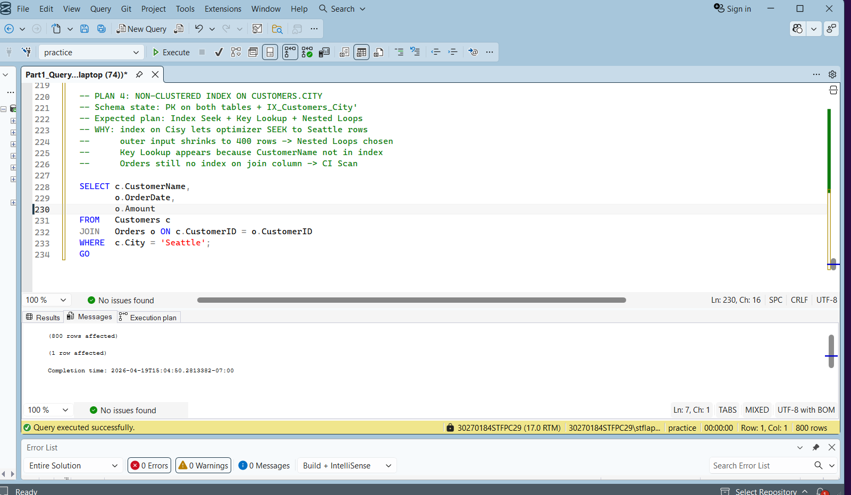
Plan 4 – option 1(for fixing plan 4):
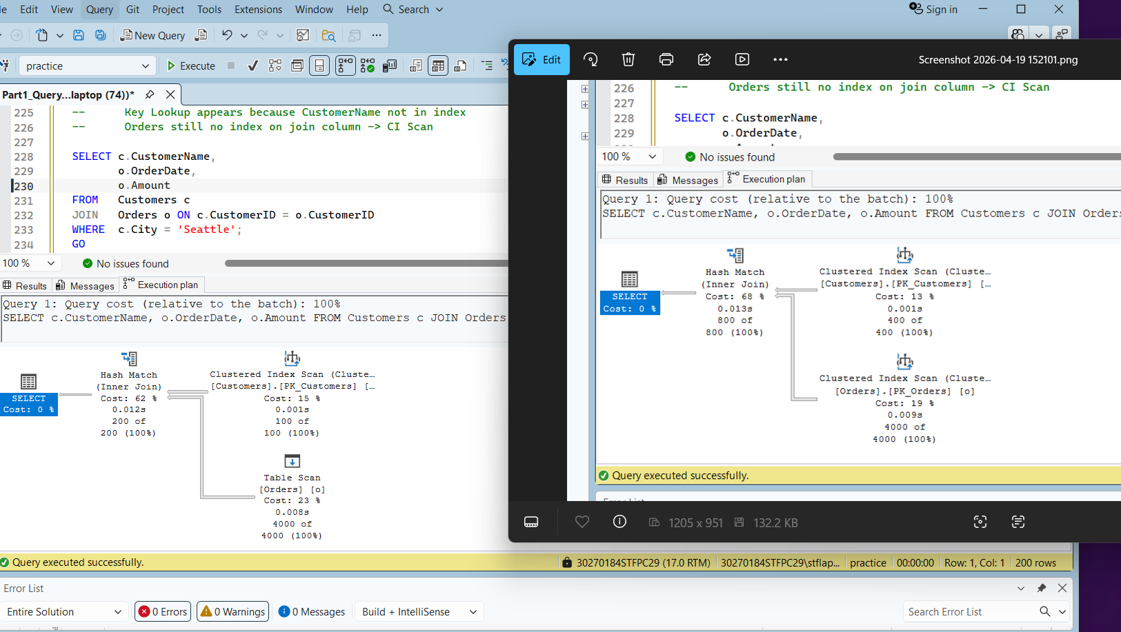

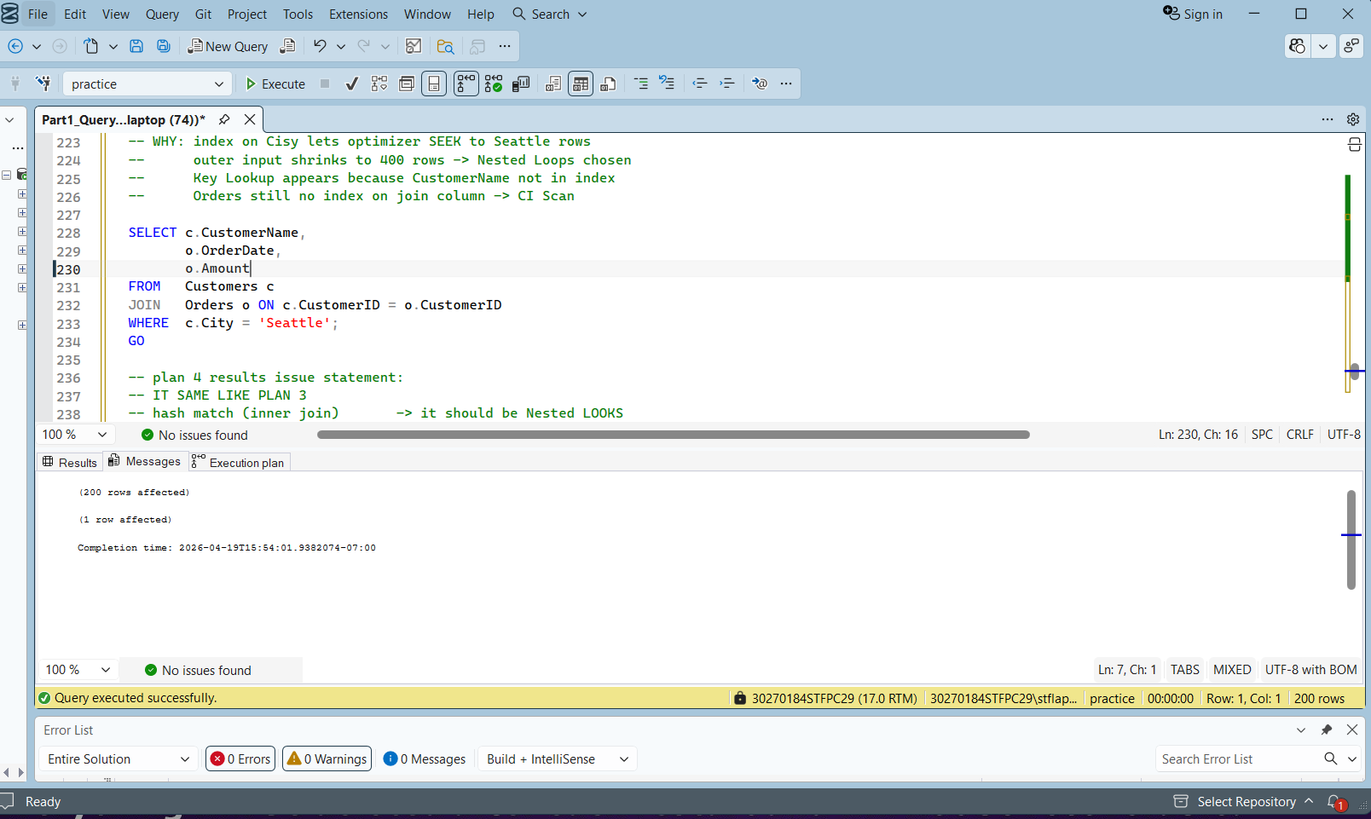
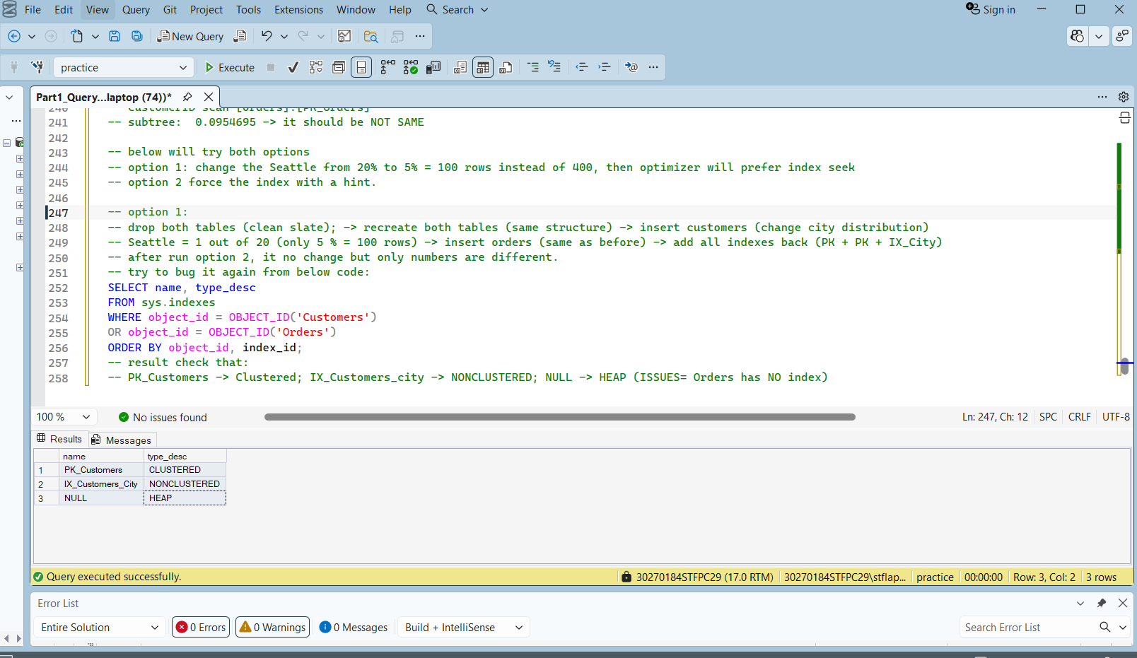
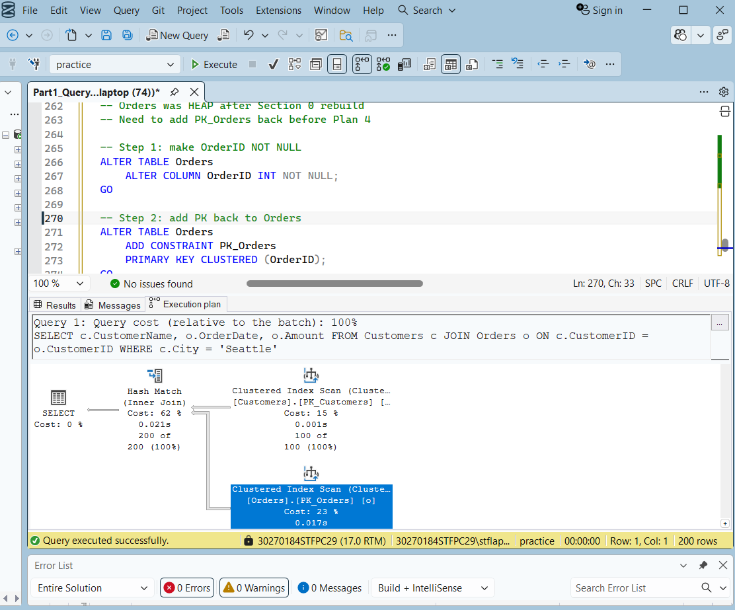
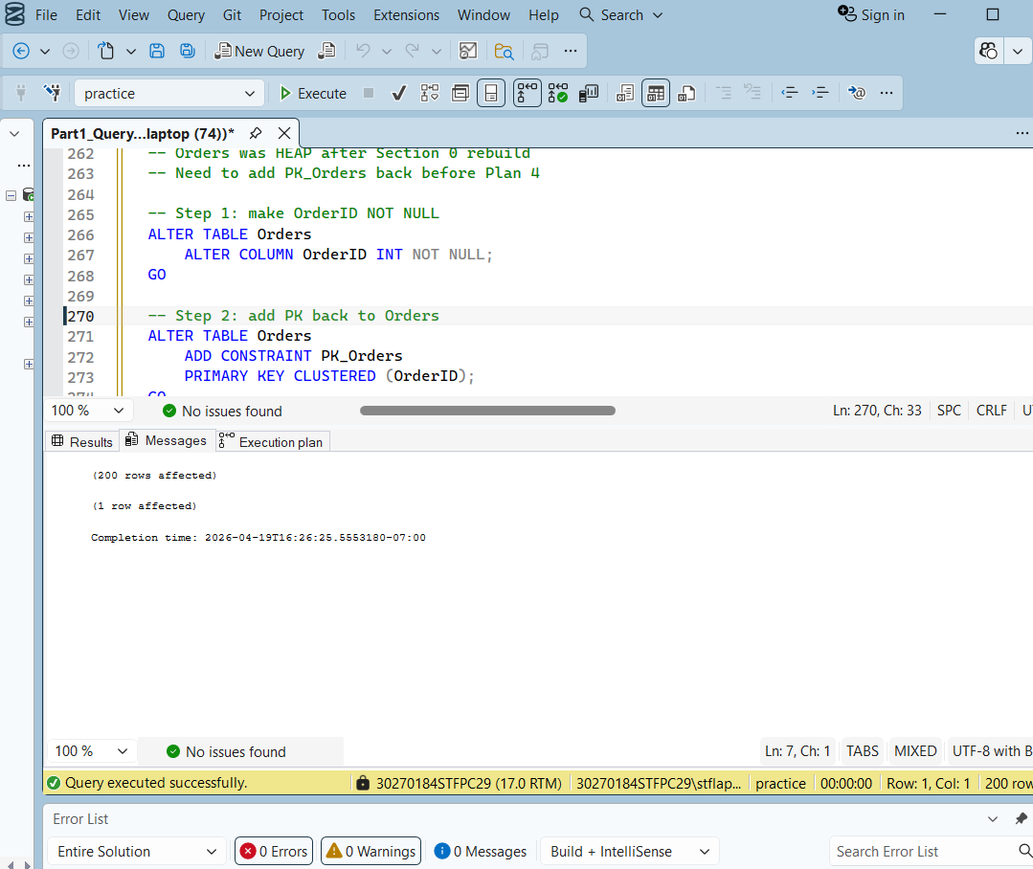
Plan 4 – option 2(for fixing plan 4):
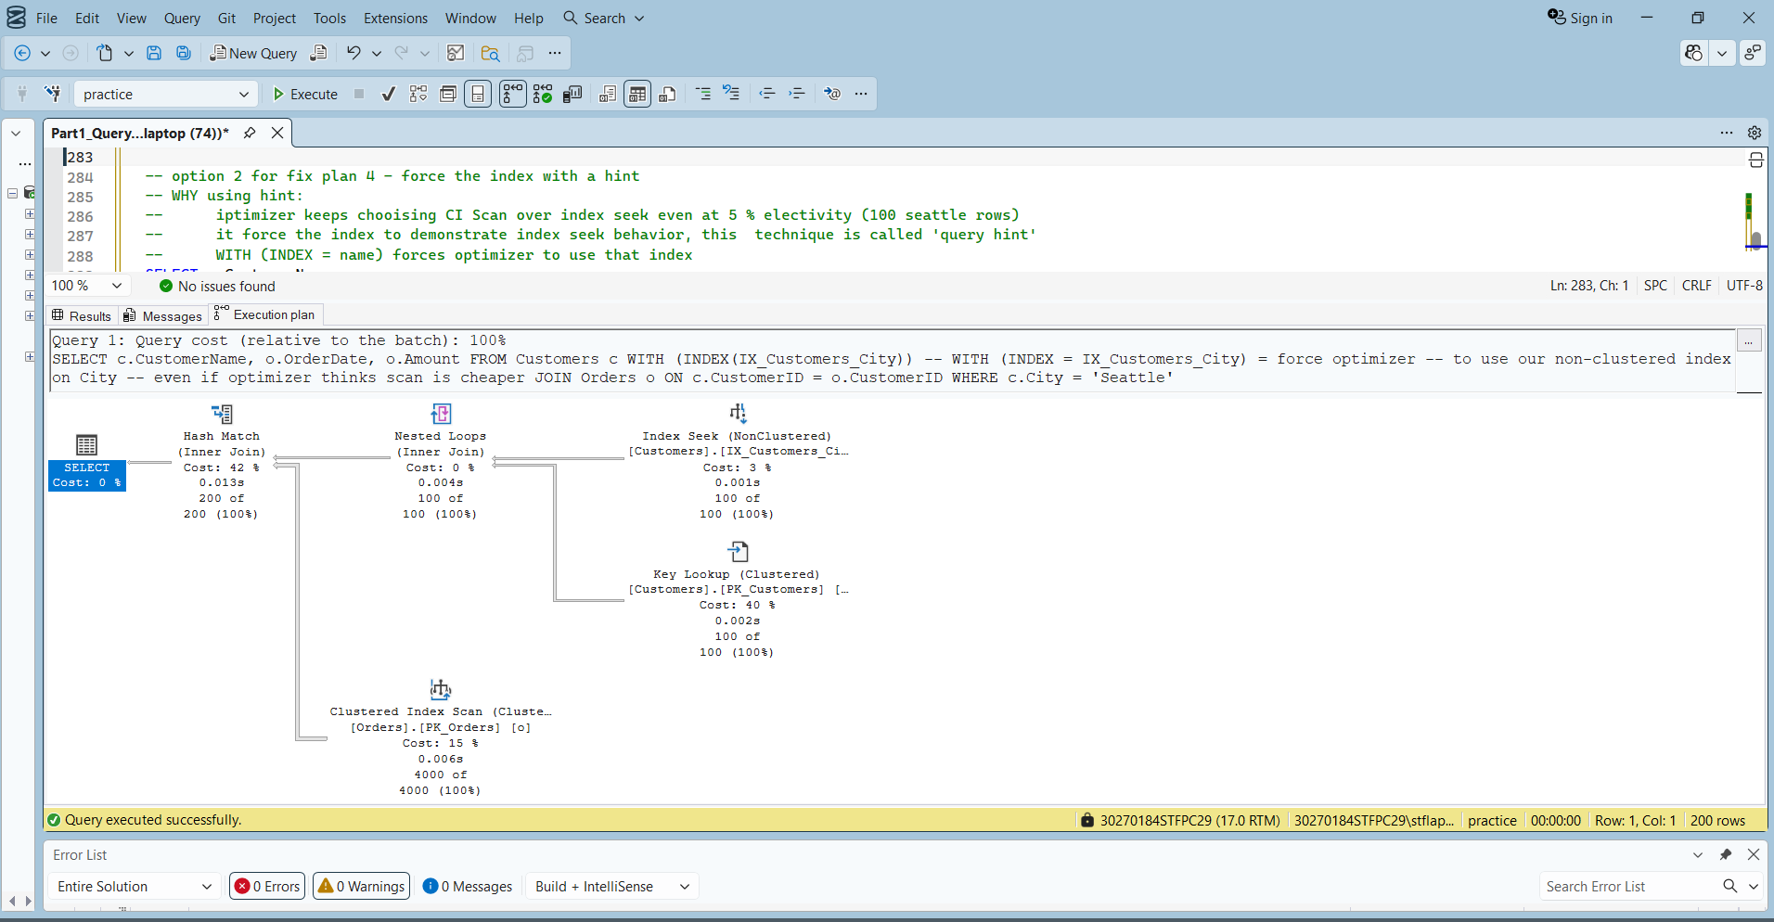
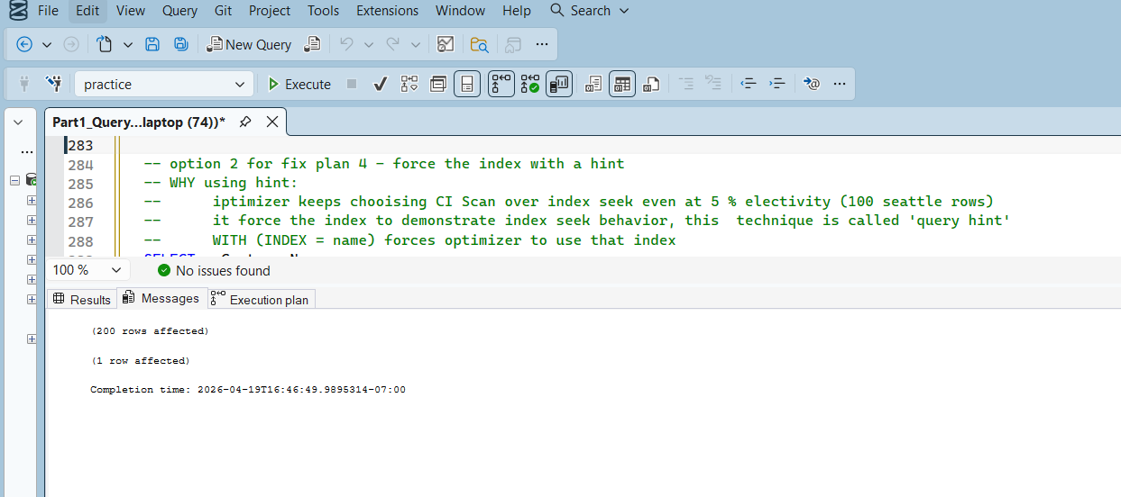
Plan 5:
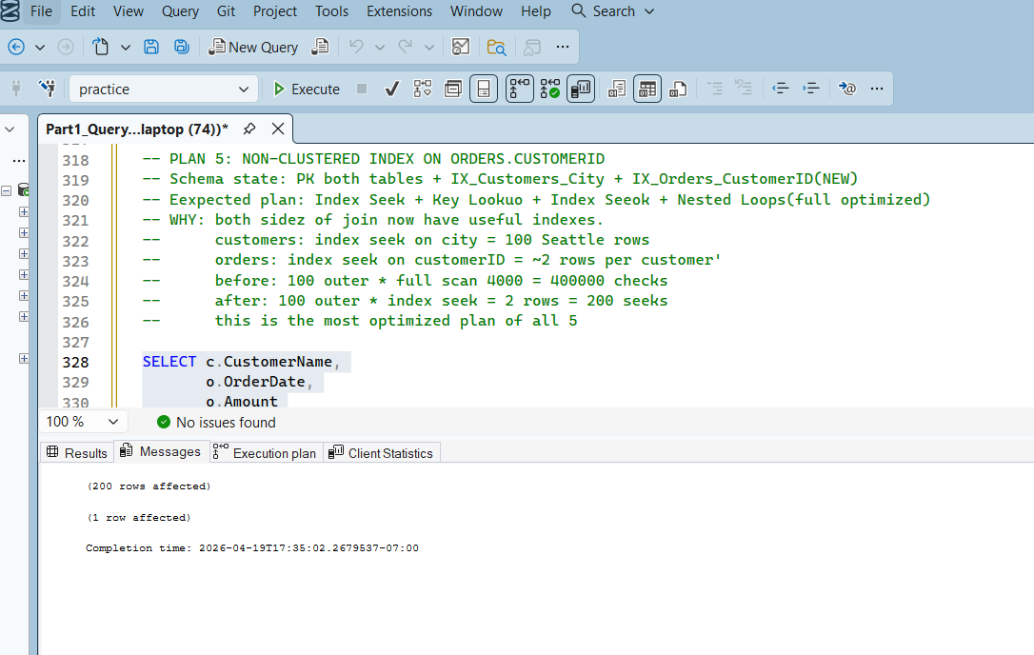
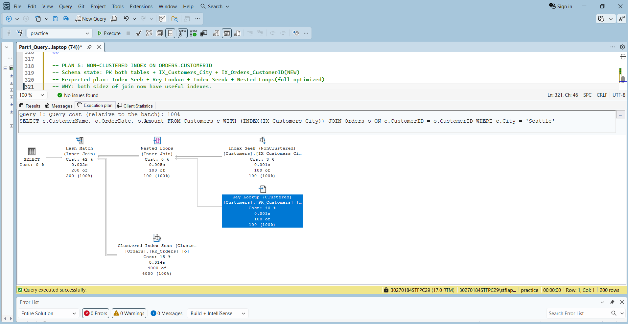
Plan 5 -1 (for fixing plan 5):
